
SRM Institute of Science and Technology
OFFLINE MODE
SET C
College of Engineering and Technology
DEPARTMENT OF ECE
SRM Nagar, Kattankulathur – 603203, Chengalpattu District, Tamil Nadu
Academic Year: 2021-2022 (EVEN)
Test: CLAT- 1 Date: 18-04-2022
Course Code & Title: 18ECC202J – Linear Integrated Circuits Duration: 60 minutes
Year & Sem: II / IV Max. Marks: 25

Course Articulation Matrix:
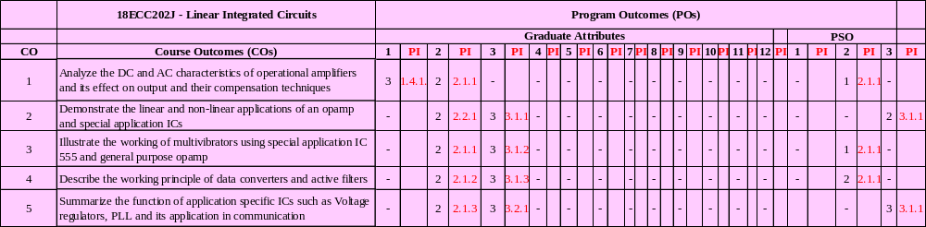

Part – A
(5 x 1 = 5 Marks)
Instructions: Answer all questions
Q. No | Question | Marks | BL | CO | PO | PI Code
1 | In IC 741, The temperature range for military specification grade is from  a. -55°C to +125°C  b. -20°C to +85 °C  c. -55°C to +225°C  d. 0°C to +70°C | 1 | 1 | 1 | 1 | 1.4.1
2 | Gain-Bandwidth (GB) product of an IC 741 op-amp is  a. Bandwidth of the op-amp, when the gain is 1  b. Bandwidth of the op-amp, when the gain is infinity  c. Bandwidth of the op-amp, when the gain is 0  d. Not related to bandwidth | 1 | 1 | 1 | 1 | 1.4.1
3 | A voltage follower has  a. High input impedance and high output impedance  b. High input impedance and low output impedance  c. Low input impedance and high output impedance  d. Low input impedance and low output impedance | 1 | 1 | 1 | 1 | 1.4.1
4 | What is the value of compensative resistance needed to reduce the effect of input bias current for the non-inverting amplifier having input resistance R1=5 KΩ and feedback resistance RF=15 KΩ?  a.2.75 KΩ b.3.75 KΩ  c.4.5 KΩ d.3.5 KΩ | 1 | 3 | 1 | 2 | 2.1.1
5 | What is the phase angle of open-loop op-amp for corner frequency is 100 Hz and the operating frequency is 90 Hz?  a.-30.8 b. -45.6  c.-35.6 d. -41.9 | 1 | 3 | 1 | 2 | 2.1.1
Part – B
(10 x 2 = 20 Marks)
Instructions: Answer any 2
6.a | Design an amplifier with a gain of +12 and input resistance equal to 10 kΩ. | 4 | 3 | 1 | 2 | 2.1.1
6.b | Explain the circuit diagram of differential amplifier and obtain the expressions for the differential gain. | 6 | 2 | 1 | 1 | 1.4.1
7.a | How input offset current is compensated in the op-amp? Explain in detail with necessary diagram. | 6 | 2 | 1 | 1 | 1.4.1
7.b | A 741C op-amp is used as an inverting amplifier with a gain of 60. The voltage gain vs frequency curve of 741C is flat up to 25 kHz. What maximum peak to peak input signal can be applied without distorting the output? | 4 | 4 | 1 | 2 | 2.1.1
8. | With neat diagram explain the external compensation techniques. | 10 | 2 | 1 | 1 | 1.4.1

Course Outcome (CO) and Bloom’s level (BL) Coverage in Questions
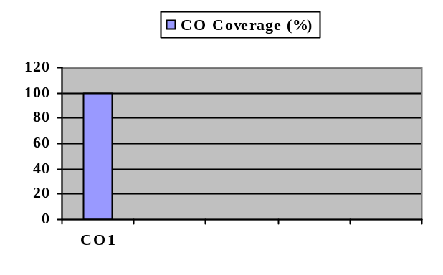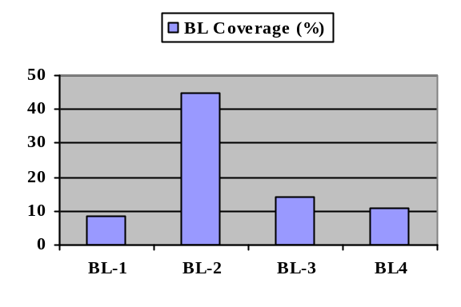
Evaluation Sheet
Name of the Student:
Register No.: RA2011004010

 |  | Part- A ALL FIVE (5x 1= 5 Marks)
Q. No | CO | Marks Allotted | Marks Obtained | Total
1 | 1 | 1
2 | 1 | 1
3 | 1 | 1
4 | 1 | 1
5 | 1 | 1
Part- B Any TWO (2 x 10= 20 Marks)
6.a | 1 | 4
6.b | 1 | 6
7.a | 1 | 6
7.b | 1 | 4
8. | 1 | 10

Consolidated Marks:

CO | Max. Marks Allotted | Marks Scored
CO1 | 25
Total | 25

Approved by the Course Coordinator
SRM Institute of Science and Technology
OFFLINE MODE
SET D
College of Engineering and Technology
DEPARTMENT OF ECE
SRM Nagar, Kattankulathur – 603203, Chengalpattu District, Tamil Nadu
Academic Year: 2021-2022 (EVEN)
Test: CLAT- 1 Date: 18-04-2022
Course Code & Title: 18ECC202J – Linear Integrated Circuits Duration: 60 minutes
Year & Sem: II / IV Max. Marks: 25

Course Articulation Matrix:

Part – A
(5 x 1 = 5 Marks)
Instructions: Answer any 5
Q. No | Question | Marks | BL | CO | PO | PI Code
1 | _____ and ____ are offset voltage null pins in µA741  a.1 and 8  b.5 and 8  c.1 and 5  d.1, 5 and 8 | 1 | 1 | 1 | 1 | 1.4.1
2 | The gain of an operational amplifier rolls -off at higher frequencies, due to which component?  a. Resistor  b. Capacitor  c. Inductor  d. Diode | 1 | 1 | 1 | 1 | 1.4.1
3 | The open loop bandwidth of µA 741 is  a.1 Hz b.10 Hz  c. 100 Hz d. 1000 Hz | 1 | 1 | 1 | 1 | 1.4.1
4 | The maximum undistorted peak to peak output voltage of a voltage follower circuit with a slew rate= 0.5 v/µs and a maximum frequency of 10 KHz is  a.3.98 volt b.1.99 volt  c.7.96 volt d.5 volt | 1 | 3 | 1 | 2 | 2.1.1
5 | Calculate the maximum output offset voltage for the inverting amplifier having input resistance R1 =10 KΩ and feedback resistance RF=100 KΩ caused by the input bias current of 400 nA.  a.40 mV b.4 mV  c.400 mV d.4 V | 1 | 3 | 1 | 2 | 2.1.1
Part – B
(10 x 2 = 20 Marks)
Instructions: Answer any 2
6.a | What is a voltage follower? Sketch the circuit. | 4 | 1 | 1 | 1 | 1.4.1
6.b | Explain the functions of various stages in an op-amp using its internal block diagram | 6 | 2 | 1 | 1 | 1.4.1
7.a | Explain in detail the inverting & non inverting amplifier and derive the expression for closed loop gain. | 6 | 2 | 1 | 1 | 1.4.1
7.b | A non-inverting amplifier with a gain of 100 is nulled at 20ºC. What will happen to the output voltage if the temperature raises to 55 º C for an offset voltage drift of 0.2 mV/º C. | 4 | 4 | 1 | 2 | 2.1.1
8.a. | Design an amplifier with a gain of -15 and input resistance equal to 10kΩ. | 4 | 3 | 1 | 2 | 2.1.1
8.b | How input offset voltage is compensated in the op-amp? Explain in detail with necessary diagram. | 6 | 2 | 1 | 1 | 1.4.1

Course Outcome (CO) and Bloom’s level (BL) Coverage in Questions

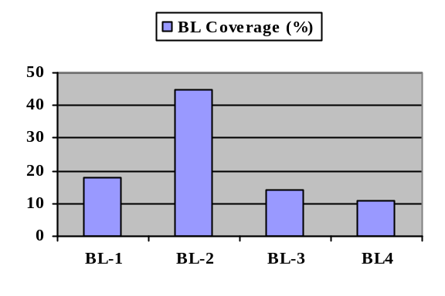
Evaluation Sheet
Name of the Student:
Register No.: RA2011004010

 |  | Part- A ALL FIVE (5x 1= 5 Marks)
Q. No | CO | Marks Allotted | Marks Obtained | Total
1 | 1 | 1
2 | 1 | 1
3 | 1 | 1
4 | 1 | 1
5 | 1 | 1
Part- B Any TWO (2 x 10= 20 Marks)
6.a | 1 | 4
6.b | 1 | 6
7.a | 1 | 6
7.b | 1 | 4
8.a | 1 | 4
8.b | 1 | 6

Consolidated Marks:

CO | Max. Marks Allotted | Marks Scored
CO1 | 25
Total | 25

Approved by the Course Coordinator

